**Group Project 3 (by group 10)**

**Data Protocol**

First, import the dataset into Python by the code:

data = pd.read_csv('option_volatility.csv')

Then extract the volatilities when the ‘day_to_event’ column’s value is -5, -4, -3, 3, 4 or 5:

shock_n5 = data.loc[data['day_to_event']==-5,'option_volatility']

shock_n4 = data.loc[data['day_to_event']==-4,'option_volatility']

shock_n3 = data.loc[data['day_to_event']==-3,'option_volatility']

shock_3 = data.loc[data['day_to_event']==3,'option_volatility']

shock_4 = data.loc[data['day_to_event']==4,'option_volatility']

shock_5 = data.loc[data['day_to_event']==5,'option_volatility']

After that, let shock_3, shock_4, shock_5, shock_n3, shock_n4, shock_n5 have the same index:

shock_n4.index = shock_n5.index

shock_n3.index = shock_n5.index

shock_3.index = shock_n5.index

shock_4.index = shock_n5.index

shock_5.index = shock_n5.index

Then, calculate the average of implied volatilities at t = -3, -4, -5, which represents the volatility before the announcement (**prior-event volatility**) , by the code:

shock_n = (shock_n5+shock_n4+shock_n3)/3

Then, calculate the average of implied volatilities at t = 3, 4, 5, which represents the volatility after the announcement (**post-event volatility**), by the code:

shock_p = (shock_5+shock_4+shock_3)/3

Also, calculate the shock effects:

shock_diff = shock_p - shock_n

Finally, concatenate the shock_n and shock_diff, and export the dataset:

names = ['date_of_event','security_id','earnings_surprise']

data_rest = shock_n5 = data.loc[data['day_to_event']==-5, names]

data_diff = pd.concat([data_rest,shock_diff,shock_n],axis=1)

data_diff.to_csv('shock_diff.csv')

**Graph 1**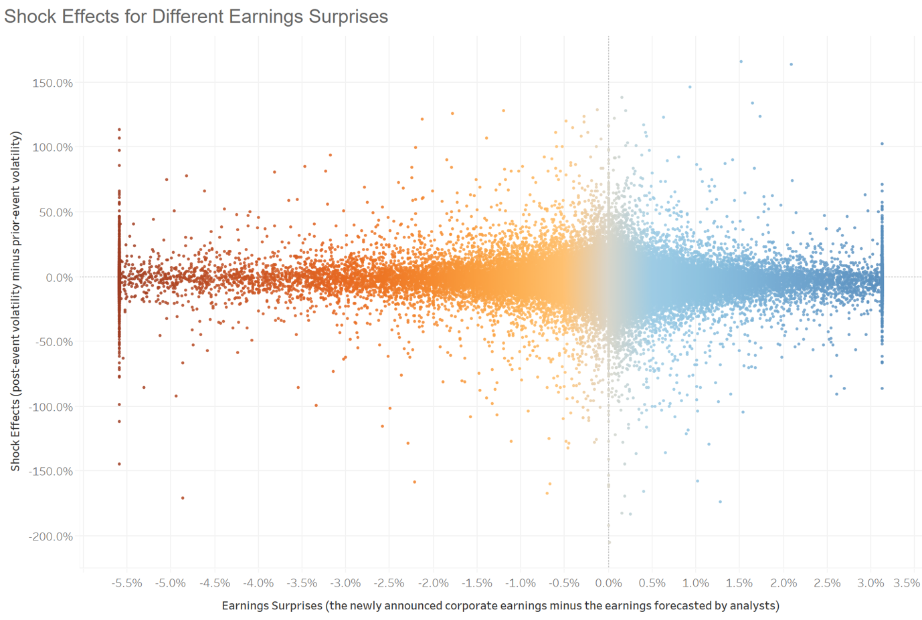

Graph 1 shows the change of volatility before and after the announcement under different earnings surprise. As can be seen in Graph 1, earnings surprise的数据在越靠近0点时越密集，which indicates that 大部分情况下，分析师对公司盈利的估计是较准确的。

Moreover, when the newly announced corporate earning equals to the earning forecasted by analysts, that is, when earning surprise equals 0, the company would has the largest shock effect, on average. As the difference between the actual earning and the predicted earning gets larger, the absolute value of earning surprise would become larger and the shock effect would get smaller.

**Graph 2**

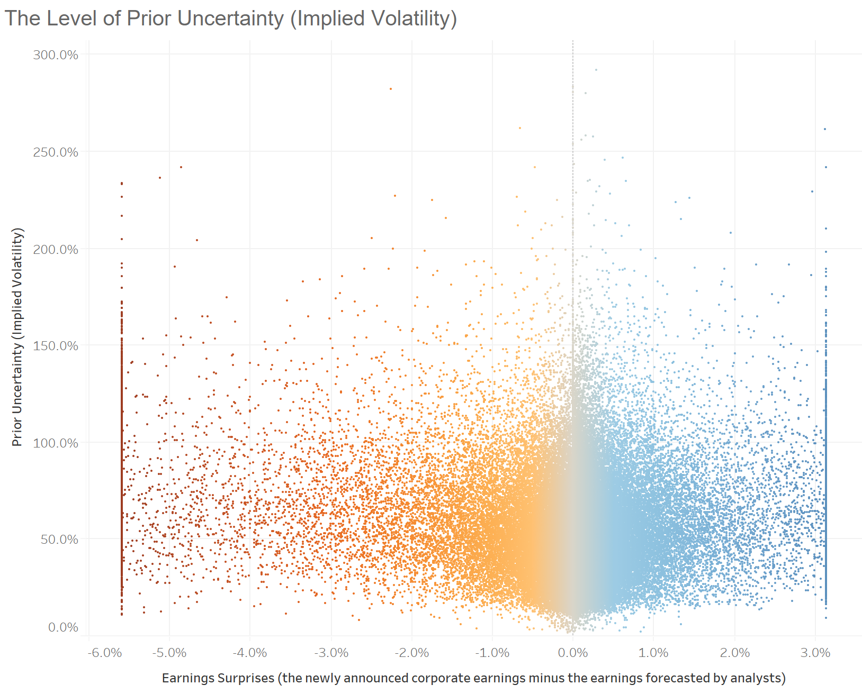

Graph 2 shows the relationship between the level of prior uncertainty (prior-event volatility) and the earnings surprises. As can be seen in the graph, the prior uncertainty roughly achieves the largest when the earning surprise equals 0. 并且，the prior uncertainty的分布形式和Graph 1类似：数据在earnings surprise靠近0时更密集.

**Conclusion**

当Earnings Surprise更接近0时，investors have a large degree of uncertainty. 换句话说，当发布信息前，公司implied volatility越高，公司的实际earnings与分析师预测的earnings越接近。这对于预测公司实际earnings有很大的价值，因为prior-event volatility是可以提前知道的。